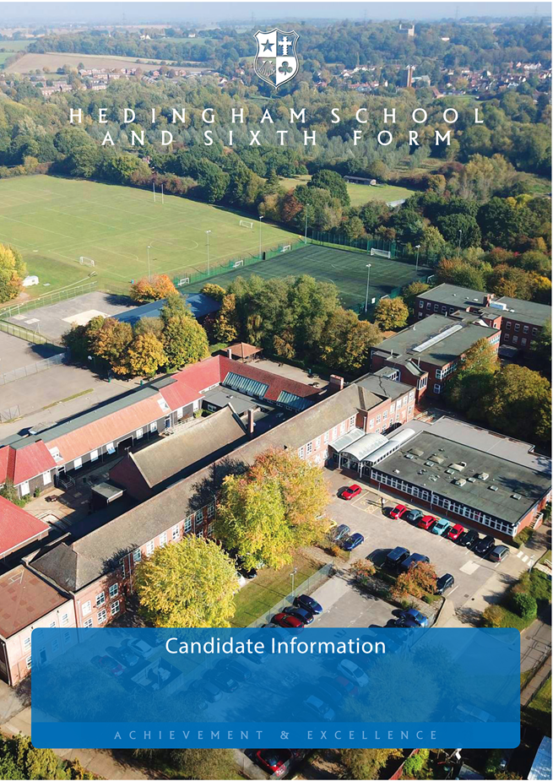

**Teacher of Science/Physics**

December 2023

**OFFICIAL SENSITIVE**

Dear Candidate

Thank you for your interest in this position, and in Hedingham School.

Please find enclosed an Application Pack outlining the process you should follow. I appreciate the time and effort it takes to prepare and make an application and I thank you in advance. When writing your Application, please address the job description and person specification enclosed and explain why you are equipped to move into this role, specifically at Hedingham School.

The closing date for applications is 29 January 2024.

Should you wish to discuss the role prior to making an application, please contact Mrs Keeley Hillman or Dr James Finn by email at [hed.hillmank@hedingham.essex.ch.uk](mailto:hed.hillmank@hedingham.essex.ch.uk) or [hed.finnj@hedingham.essex.sch.uk](mailto:hed.finnj@hedingham.essex.sch.uk) respectively.

I look forward to receiving your application.

Yours sincerely

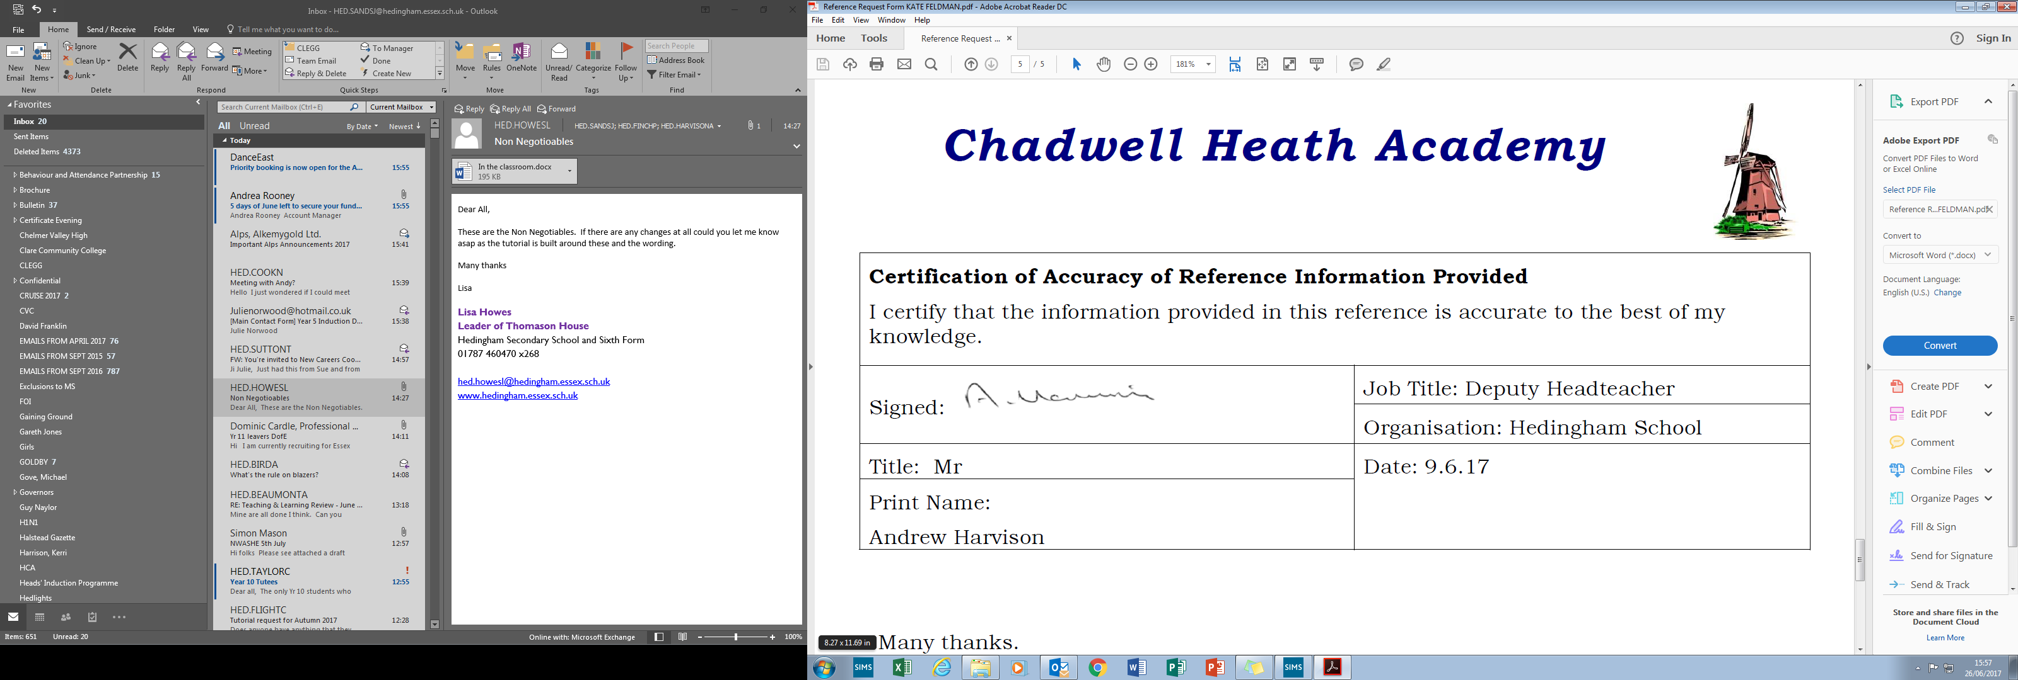

Mr A Harvison

Headteacher



**Hedingham School - Context**

Hedingham School and Sixth Form is an over-subscribed, independent Academy situated in an attractive village in North Essex (within easy reach of Braintree, Chelmsford, Colchester and South Suffolk). Our students are polite and engaged and love to learn and our parental body is highly supportive. As one student recently put it when speaking to an Ofsted inspector, “The school values shape us into adults.”

We are a school that values its history, maintaining traditional events and initiatives that are deep rooted in the local community whilst embracing new technologies, such as our offer of T-level Digital Business Services in our new state of the art T-level building, alongside our rural vocational centre supporting students towards pathways into local industry including agriculture.

Hedingham School provides a high-quality educational experience for all students and strives to ensure that each individual’s academic and personal development is fulfilled.

We offer a vibrant learning environment where students are encouraged to ‘think’ and explore strategies to grasp and apply knowledge.

The curriculum offered is purposeful and stimulating, allowing students to build a range of skills as they progress through school.

We want our students to be resilient and take on the challenges of the 21st century. We encourage them to approach school with confidence and participate fully in all aspects of school life.

At Hedingham School, our students support and care for each other and display high levels of respect for all members of the community. Hedingham School has a strong ‘culture’ which actively promotes equality of opportunity, allowing all students to pursue their ambitions.

We believe in building strong partnerships with parents, based on trust and confidence.



**Ofsted 2023**

**Mission Statement**

Hedingham School seeks to create a challenging and stimulating learning environment that encourages high expectations for all learners.  Students are prepared for life in the 21st century through a safe, caring and supportive environment.  We strive to foster positive relationships with students and staff, offering mutual respect for all members of the community.’

Our School Motto is:

‘Ready’, ‘Respect’, ‘Safe’

**Vision**

This vision is driven through our school curriculum.  Our aim is to ensure that the curriculum delivers the following principles:

* To provide the **knowledge and skills** required to be successful learners
* To create **resilient and independent** learners who are able to meet the challenges of the 21st century
* To **prepare** learners for the next step in their education
* To **broaden their horizons** through a rich and varied **enrichment** programme
* To encourage learners to be **active citizens** who contribute positively to the**community**

**Why Work With Us?**

**We care about your well-being:**

At Hedingham School and Sixth Form, our teachers’ well-being really matters. That’s why our leadership team carefully consider the impact that every decision will have on staff workload (Ofsted – March 2023). We value the importance of our staff and recognise the direct impact that they have on shaping the futures of our students. As such, we continually try to forge an environment in which they can flourish and develop.

Twice a term, we also have well-being weeks, which clear the calendar and enable staff to indulge in yoga, badminton, art classes or whatever encourages them to unwind and interact with colleagues.

**Opportunities for career progression:**

Staff are consistently offered opportunities to progress their career within the school as well as undertake whole school temporary projects as a stepping stone to wider responsibilities. Many of our staff that have taken on leadership roles in the school have progressed from within.

**Training Opportunities:**

We have a strong commitment to continuous professional development, using both internal and external expertise, with currently more than 20 team members undertaking National Professional Qualifications supported by the school. Many of our staff are Lead Subject Mentors for the local ITT hub. We encourage staff to lead CPD with colleagues but offer remission time to plan and refine their training sessions on the recognition that one hours high quality delivery often requires 5 hours in the planning.

**Be involved in our broad curriculum offer:**

As a teacher, often part of the enjoyment of working with children comes from experiences out of the classroom. We offer opportunities for staff to be involved in trips and visits including water sports trips, ski trips, theme park visits, New York, Duke of Edinburgh as well as more local visits that are built into subject curriculum offer as well as our wider personal development programme.

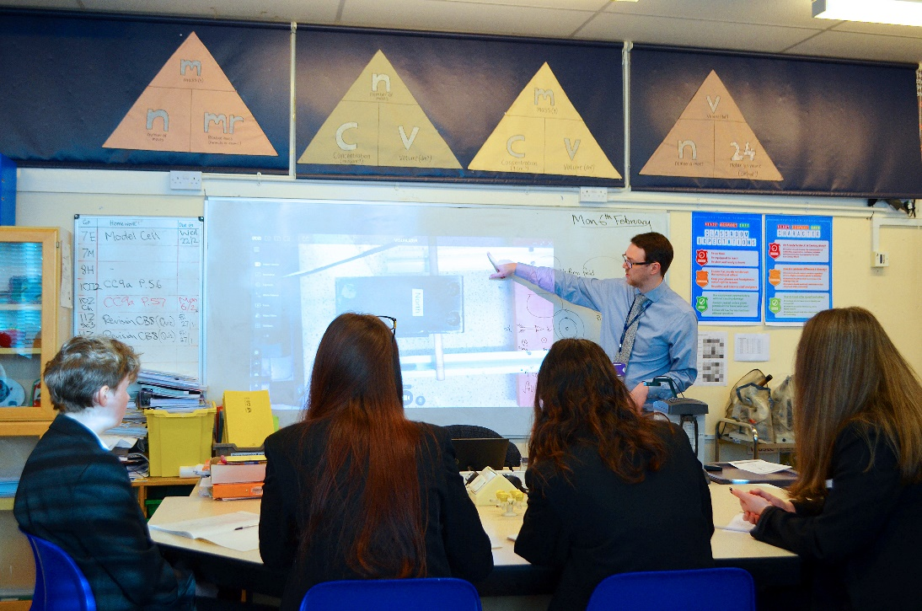

**The Science Learning Area**

The Science Learning Area has a team of ten teachers and four highly qualified technicians. It is very well resourced with recently refurbished laboratories and many ICT facilities. The Science Learning Area benefits from frequent use of Hedingham School’s extremely well-resourced Learning Centre and has a developing extra-curricular programme including Iceland, CERN, The Sanger Institute, National History Museum and Colchester Zoo.

The Science Learning Area has a well-structured, simple, marking and assessment policy, focused on ensuring students receive timely feedback and minimising teacher workload. Overall staff workload and well-being is primarily considered during any changes in the department structure.

At Key Stage 3, students are taught in broad ability bands based on their Key Stage 2 data and CAT scores. At Key Stage 4, students are set using their performance during Key Stage 3 and whether they have opted for Triple Science. The school currently uses the Edexcel suite of GCSE qualifications for GCSE.

The uptake of students to AS and A2 at Hedingham School courses is strong and there is A Level teaching available for the right candidate.

Student achievement in Science is moving towards outstanding with the Combined Science and Triple Science results in the top 10% of all schools nationally for the past 3 years.

Staffing

Leader of Science Learning Area:   
Dr James Finn

Second in Charge of Science   
Mrs Rosanne Taylor

Postholders in Science:   
Mr Rupert Sanders

Miss Eve Duncan

Teachers of Science:

Mrs Sandra Burmicz

Mrs Rebecca Goodwins

Mrs Keeley Hillman

Miss Ellie Kennedy

Mr John Kirton

Mr James Pretty

Mr Colin Riches

Senior Technician:   
Mrs Lorraine Northfield

Technicians:   
Dr Fleur Radford

Mrs Katie Furlong

Mrs Amanda Stopps

Mrs Julie Ford (Admin)

**Job Description and Person Specification**

Teacher of Science

Salary: TMS/UPS

Job Description

The successful candidate should expect to perform the following responsibilities within the department:

* Teach across the age and ability range, including post 16
* Employ appropriate teaching and learning strategies and evaluate the outcomes
* Monitor the progress of students in learning groups
* Maximise student progress through providing appropriate challenge, rigour and tackling underachievement
* Maintain high standards of work, behaviour and achievement
* Assist in the evaluation and development of schemes of work together with the development of resources
* Assist in the recruitment of students for Post-16 courses

**Person Specification**

* Good graduate
* Good classroom teacher with imaginative approaches
* Clear view of the subject within the curriculum
* Awareness of recent developments within the subject
* Flexibility to cope with change
* Ability to work in a team
* ICT literate
* Willingness to contribute to extra-curricular activities and intervention
* Commitment to maintaining and raising standards of achievement for all students
* Ability to reflect upon and evaluate personal teaching practice
* Have good relationships with students

.

